# **Beamline devices**

## **Attenuator**

## **Bending magnet**

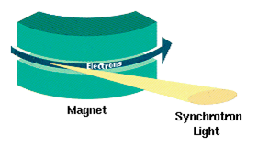

## **Collimator**

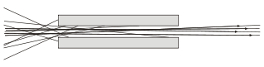

Figure 1 Example of a particle collimator

A **collimator** is a device that narrows a beam of particles or waves. To narrow can mean either to cause the directions of motion to become more aligned in a specific direction (i.e., make [collimated light](https://en.wikipedia.org/wiki/Collimated_light) or [parallel](https://en.wikipedia.org/wiki/Parallel_(geometry)) rays), or to cause the spatial [cross section](https://en.wikipedia.org/wiki/Cross_section_(geometry)) of the beam to become smaller (**beam limiting device**).

## **Compound Refractive Lens (CRL)**

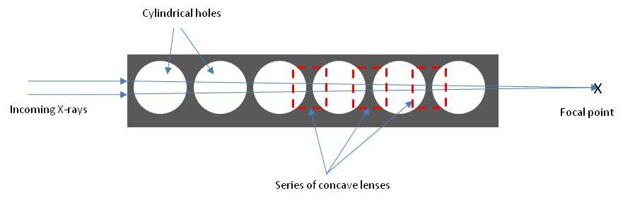

A **Compound refractive lens** (CRL) is a series of individual lenses arranged in a linear array in order to achieve focusing of [X-rays](https://en.wikipedia.org/wiki/X-rays) in the energy range of 5-40 keV. They are an alternative to the [KB mirror](https://en.wikipedia.org/wiki/Kirkpatrick-Baez_mirror).

For all materials the [refractive index](https://en.wikipedia.org/wiki/Refractive_index) for X-rays is close to 1, hence a single conventional lens for X-rays has an extremely long focal length (for practical lens sizes). In addition, X-rays attenuate as they pass through a material so that conventional lenses for X-rays have long been considered impractical. The CRL gets its reasonably short focal length, on the order of meters, by using many lenses in series. To minimize the absorption the lens must be made from a material such as [aluminium](https://en.wikipedia.org/wiki/Aluminium), [beryllium](https://en.wikipedia.org/wiki/Beryllium), or [lithium](https://en.wikipedia.org/wiki/Lithium).

## **Diffractometer**

A **diffractometer** (pronunciation: di-"frak-'tä-m&-t&r) is a measuring instrument for analyzing the structure of a material from the scattering pattern produced when a beam of [radiation](https://en.wikipedia.org/wiki/Radiation) or particles (such as [X-rays](https://en.wikipedia.org/wiki/X-ray) or [neutrons](https://en.wikipedia.org/wiki/Neutron)) interacts with it.

## **Eiger**

Area detector.

## **Goniometer**

A **goniometer** is an instrument that either measures an angle or allows an object to be rotated to a precise angular position. The term **goniometry** is derived from two Greek words, [*gōnia*](https://en.wiktionary.org/wiki/%CE%B3%CF%89%CE%BD%CE%AF%CE%B1), meaning [angle](https://en.wikipedia.org/wiki/Angle), and [*metron*](https://en.wiktionary.org/wiki/%CE%BC%CE%AD%CF%84%CF%81%CE%BF%CE%BD#Ancient_Greek), meaning [measure](https://en.wikipedia.org/wiki/Measurement).

## **Kirkpatrick-Baez mirror (KB Mirror)**

A **Kirkpatrick-Baez mirror**, or KB mirror for short, focuses beams of [X-rays](https://en.wikipedia.org/wiki/X-ray) by reflecting them at grazing incidence off a curved surface, usually coated with a layer of a heavy metal. It is named after [Paul Kirkpatrick](https://en.wikipedia.org/wiki/Paul_Kirkpatrick) and [Albert Baez](https://en.wikipedia.org/wiki/Albert_Baez), the inventors of the [X-ray microscope](https://en.wikipedia.org/wiki/X-ray_microscope).[[1]](https://en.wikipedia.org/wiki/Kirkpatrick-Baez_mirror#cite_note-1)

Although X-rays can be focused by [compound refractive lenses](https://en.wikipedia.org/wiki/Compound_refractive_lens), these also reduce the intensity of the beam and are therefore undesirable. KB mirrors, on the other hand, can focus beams to small spot sizes with minimal loss of intensity. Typically they are used in pairs - one to focus horizontally and one for vertical focus. When the horizontal and vertical focuses coincide, the X-ray beam is focused to a point.[[2]](https://en.wikipedia.org/wiki/Kirkpatrick-Baez_mirror#cite_note-2)

## **Monochromator**

A **monochromator** is an [optical](https://en.wikipedia.org/wiki/Optics) device that transmits a mechanically selectable narrow band of [wavelengths](https://en.wikipedia.org/wiki/Wavelength) of [light](https://en.wikipedia.org/wiki/Light) or other [radiation](https://en.wikipedia.org/wiki/Radiation) chosen from a wider range of wavelengths available at the input. The name is from the [Greek](https://en.wikipedia.org/wiki/Ancient_Greek) roots *mono-*, "single", and *chroma*, "colour", and the [Latin](https://en.wikipedia.org/wiki/Latin) suffix *-ator*, denoting an agent.

In hard [X-ray](https://en.wikipedia.org/wiki/X-ray) and [neutron](https://en.wikipedia.org/wiki/Neutron_radiation) optics, [crystal monochromators](https://en.wikipedia.org/wiki/Crystal_monochromator) are used to define wave conditions on the instruments.

## **Scintillator**

A **scintillator** is a material that exhibits scintillation — the property of [luminescence](https://en.wikipedia.org/wiki/Luminescence),[[1]](https://en.wikipedia.org/wiki/Scintillator" \l "cite_note-FOOTNOTELeo1994158-1) when excited by ionizing radiation.

## **Slit**

## **Undulator**

An **undulator** is an [insertion device](https://en.wikipedia.org/wiki/Insertion_device) from high-energy physics and usually part of a larger installation, a [synchrotron](https://en.wikipedia.org/wiki/Synchrotron) [storage ring](https://en.wikipedia.org/wiki/Storage_ring), or it may be a component of a [free electron laser](https://en.wikipedia.org/wiki/Free_electron_laser). It consists of a periodic structure of [dipole magnets](https://en.wikipedia.org/wiki/Dipole_magnet). The static [magnetic field](https://en.wikipedia.org/wiki/Magnetic_field) alternates along the length of the undulator with a wavelength λ u {\displaystyle \lambda \_{u}} . Electrons traversing the periodic magnet structure are forced to undergo oscillations and thus to radiate energy. The radiation produced in an undulator is very intense and concentrated in narrow energy bands in the spectrum. It is also [collimated](https://en.wikipedia.org/wiki/Collimated_light) on the orbit plane of the electrons. This radiation is guided through [beamlines](https://en.wikipedia.org/wiki/Beamlines) for experiments in various scientific areas.

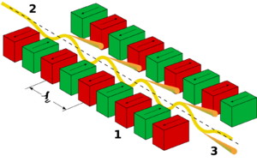

Figure 2 Working of the undulator. 1: magnets, 2: electron beam entering from the upper left, 3: synchrotron radiation exiting to the lower right

In an [undulator](https://en.wikipedia.org/wiki/Undulator) source the radiation produced by the oscillating electrons interferes constructively with the motion of other electrons, causing the radiation spectrum to have a relatively narrow bandwidth. The intensity of radiation scales as N 2 {\displaystyle N^{2}} , where N {\displaystyle N} N is the number of poles in the magnet array.

## **Wiggler**

A **wiggler** is an [insertion device](https://en.wikipedia.org/wiki/Insertion_device) in a [synchrotron](https://en.wikipedia.org/wiki/Synchrotron). It is a series of magnets designed to periodically laterally deflect ('wiggle') a beam of charged particles (invariably [electrons](https://en.wikipedia.org/wiki/Electron) or [positrons](https://en.wikipedia.org/wiki/Positron)) inside a [storage ring](https://en.wikipedia.org/wiki/Storage_ring) of a synchrotron. These deflections create a change in acceleration which in turn produces emission of broad [synchrotron radiation](https://en.wikipedia.org/wiki/Synchrotron_radiation) tangent to the curve, much like that of a [bending magnet](https://en.wikipedia.org/wiki/Bending_magnet), but the intensity is higher due to the contribution of many [magnetic dipoles](https://en.wikipedia.org/wiki/Magnetic_dipoles) in the wiggler. Furthermore, as the wavelength (λ) is decreased this means the frequency (ƒ) has increased.[[1]](https://en.wikipedia.org/wiki/Wiggler_(synchrotron)#cite_note-Australian_Synchrotron-1) This increase of frequency is directly proportional to energy, hence, the wiggler creates a wavelength of light with a larger energy.

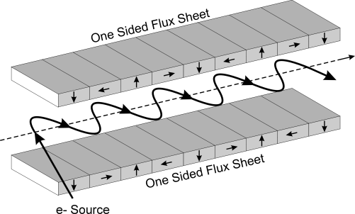

A wiggler has a broader spectrum of radiation than an [undulator](https://en.wikipedia.org/wiki/Undulator).[[1]](https://en.wikipedia.org/wiki/Wiggler_(synchrotron)#cite_note-Australian_Synchrotron-1)

Typically the magnets in a wiggler are arranged in a [Halbach array](https://en.wikipedia.org/wiki/Halbach_array). The design shown above is usually known as a Halbach wiggler.

In a [wiggler](https://en.wikipedia.org/wiki/Wiggler_(synchrotron)) the period and the strength of the magnetic field is not tuned to the frequency of radiation produced by the electrons. Thus every electron in a bunch radiates independently, and the resulting [radiation bandwidth](https://en.wikipedia.org/wiki/Bandwidth_(signal_processing)) is broad. A wiggler can be considered to be series of [bending magnets](https://en.wikipedia.org/wiki/Bending_magnet) concatenated together, and its radiation intensity scales as the number of magnetic poles in the wiggler.